Ulvi Bajarani
SID 20539914
CSCI 6345 – Advanced Computer Networks
Summer II
Assignment 1
Installing Virtual Machine
1. Some screenshots from the installation process of Virtual Box 6.1.10

The menu with choices
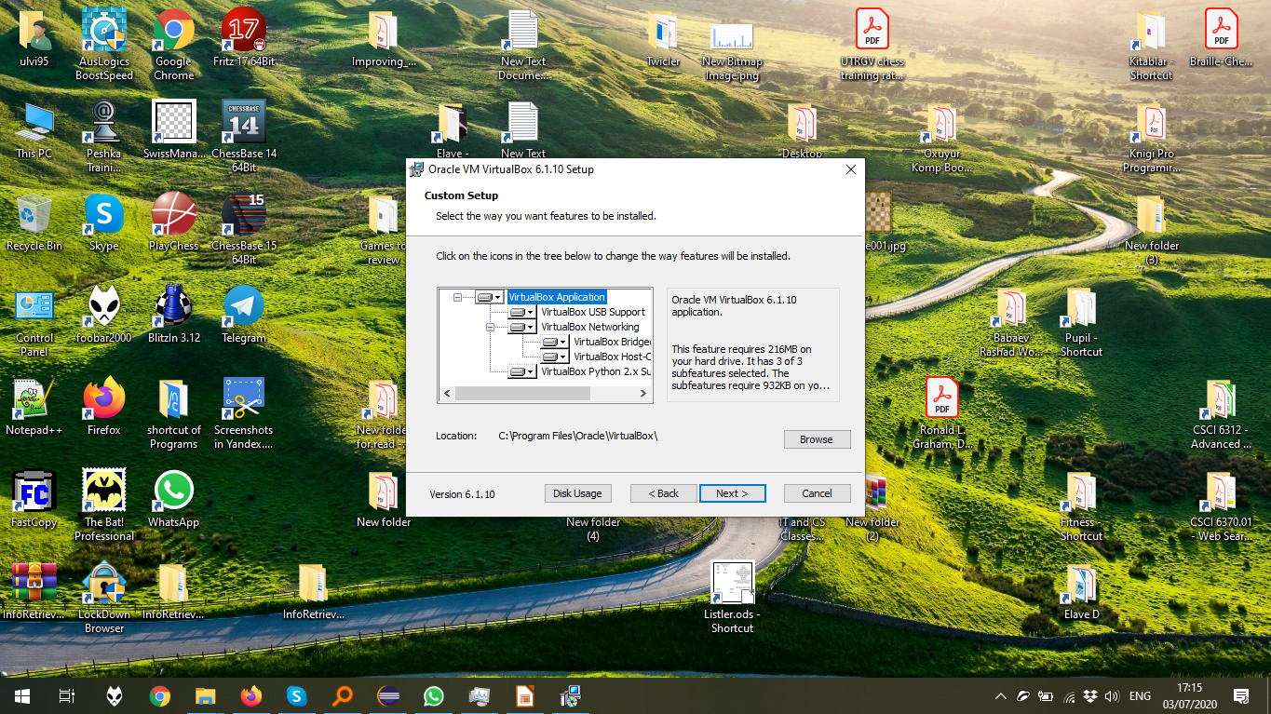
The start of the VirtualBox installation process, after all confirmations.
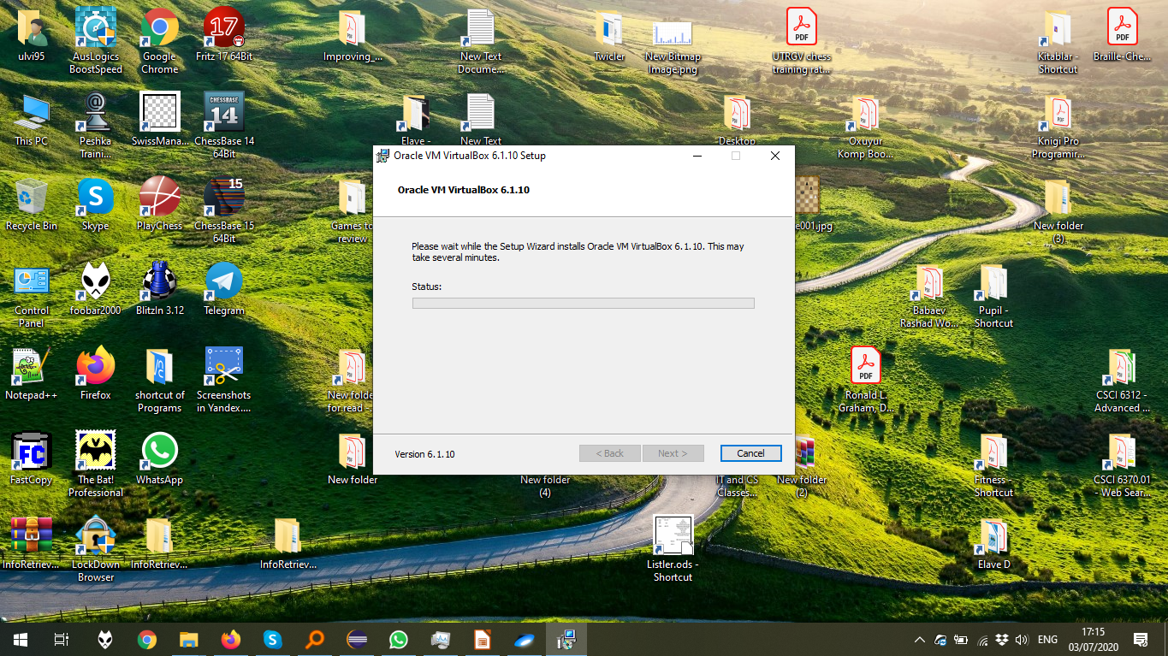
The VirtualBox window:
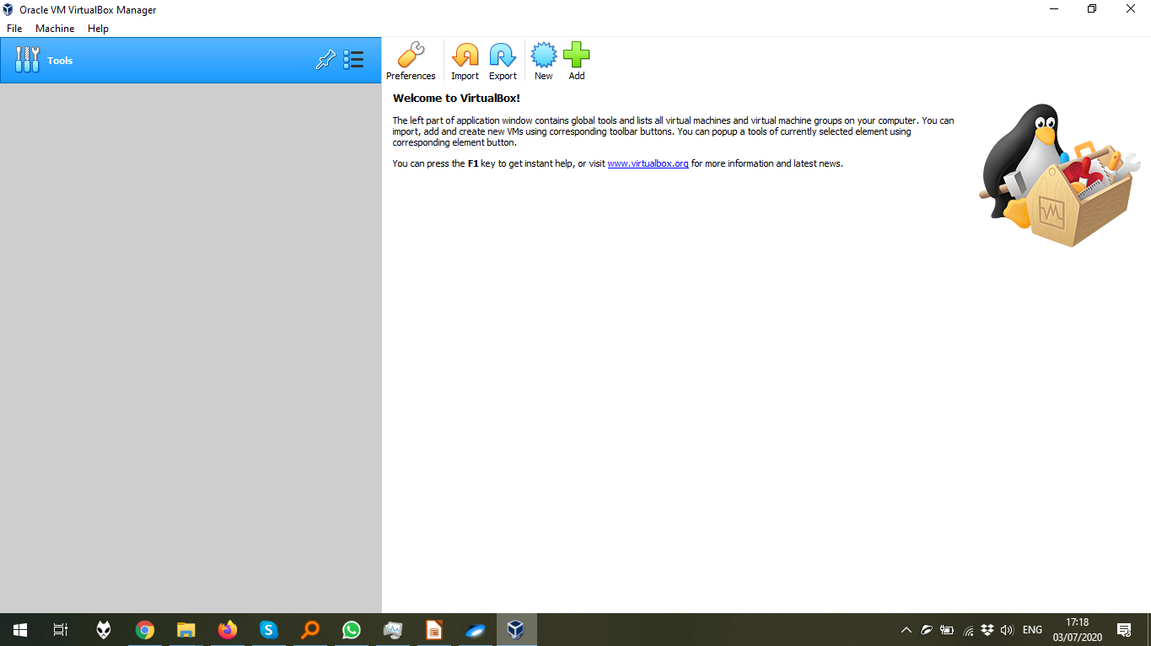
The dialog window which asks for the confirmation of VirtualBox Extension Pack
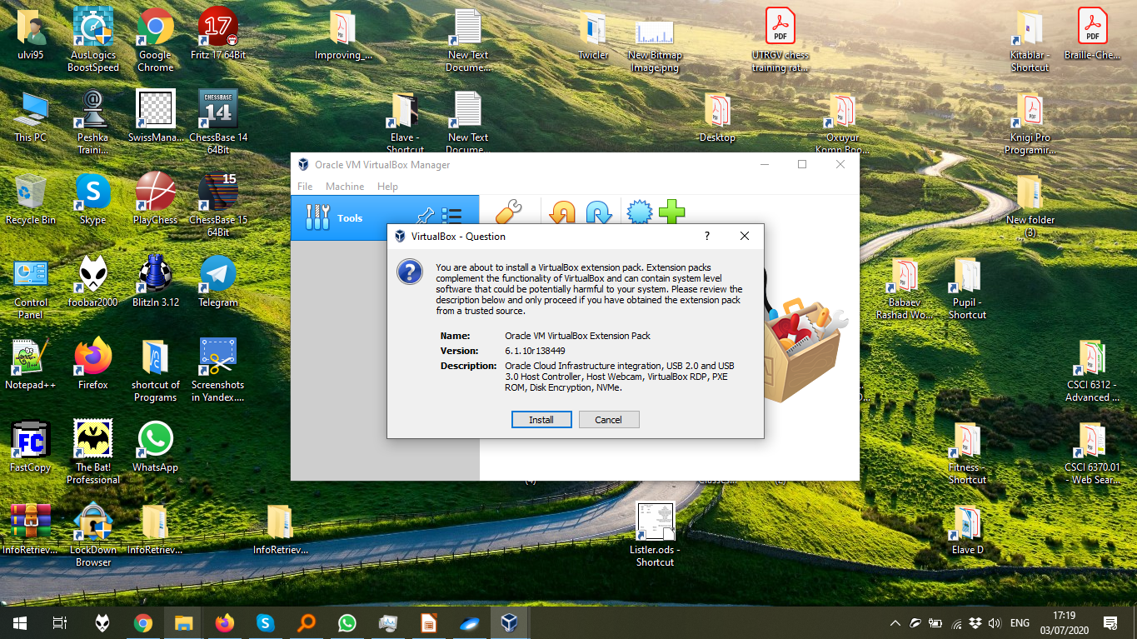
The start of the VirtualBox Extension Pack installation process, after all confirmations.
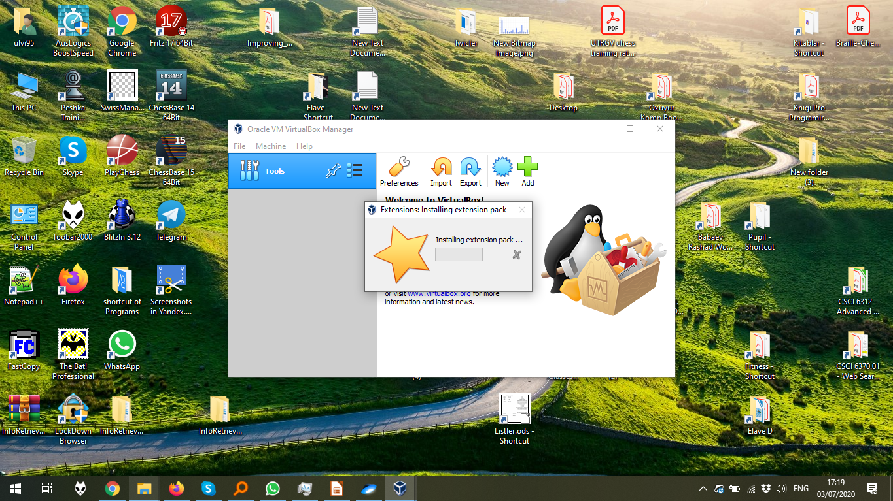

2. The Installation of Ubuntu 20.04 in the VirtualBox

The creation of the virtual machine by menu Machine > New Machine:
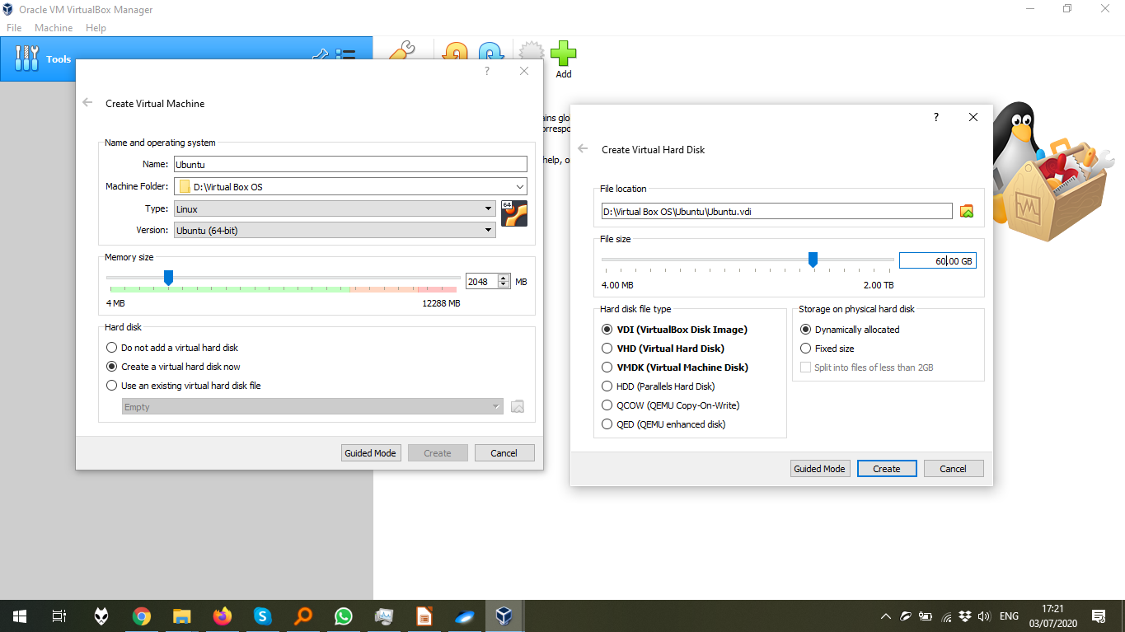

The configuration of the optical disk of the machine by Settings > Storage > the disk icon
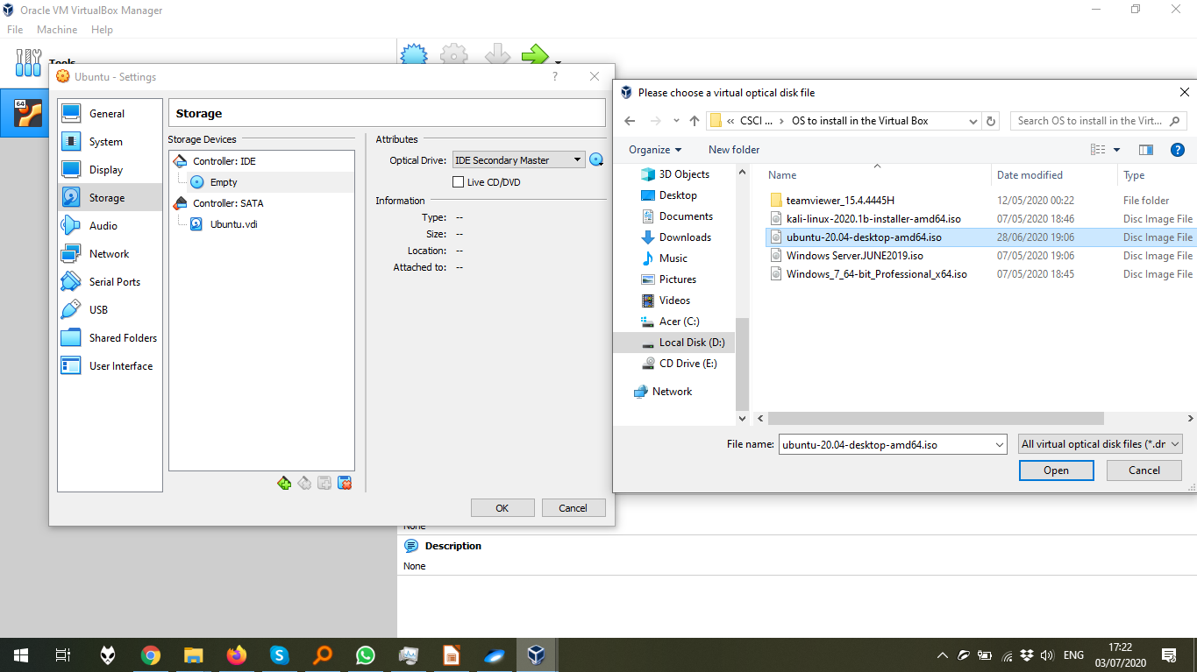
The start of the installation process after the machine starts.
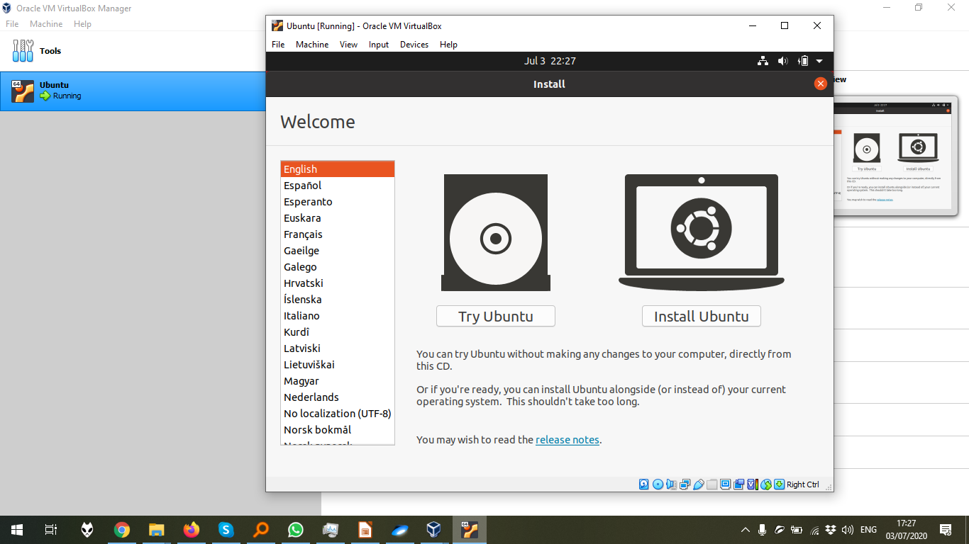
The choice menu in the installation:

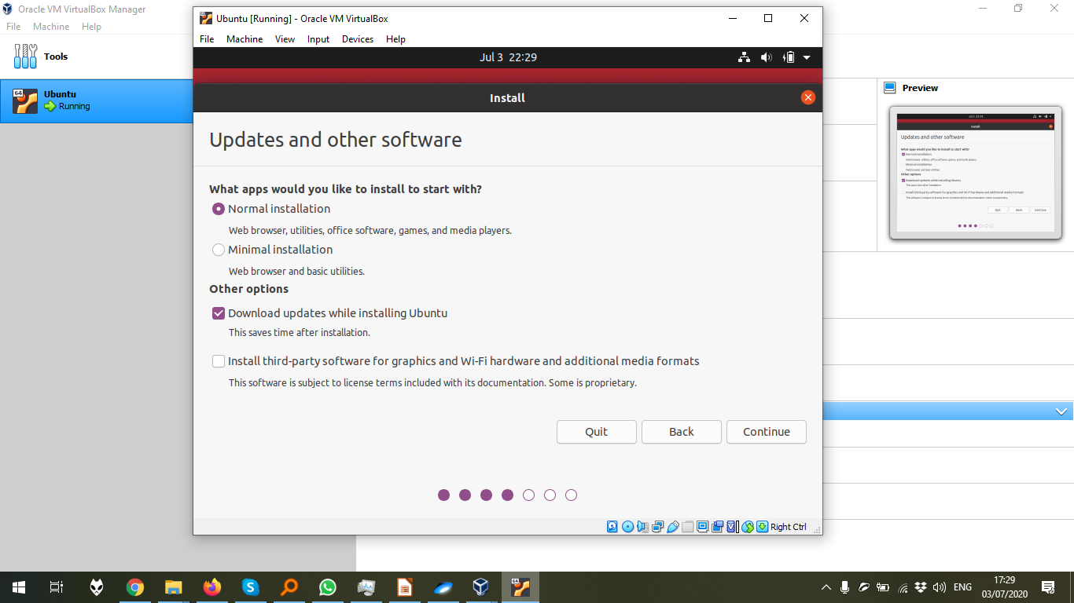
The installation process, after all confirmations.
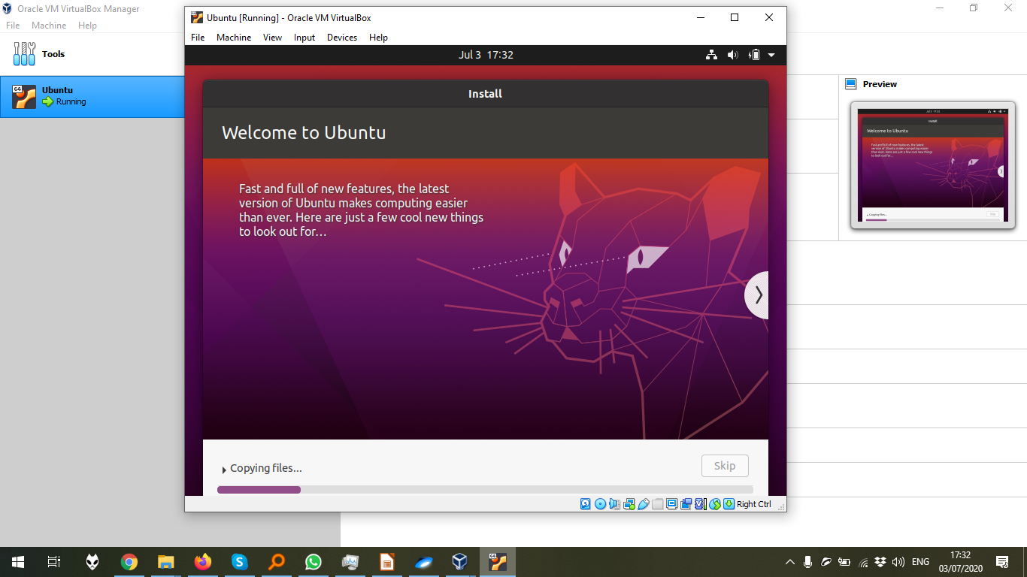
The end of the installation:

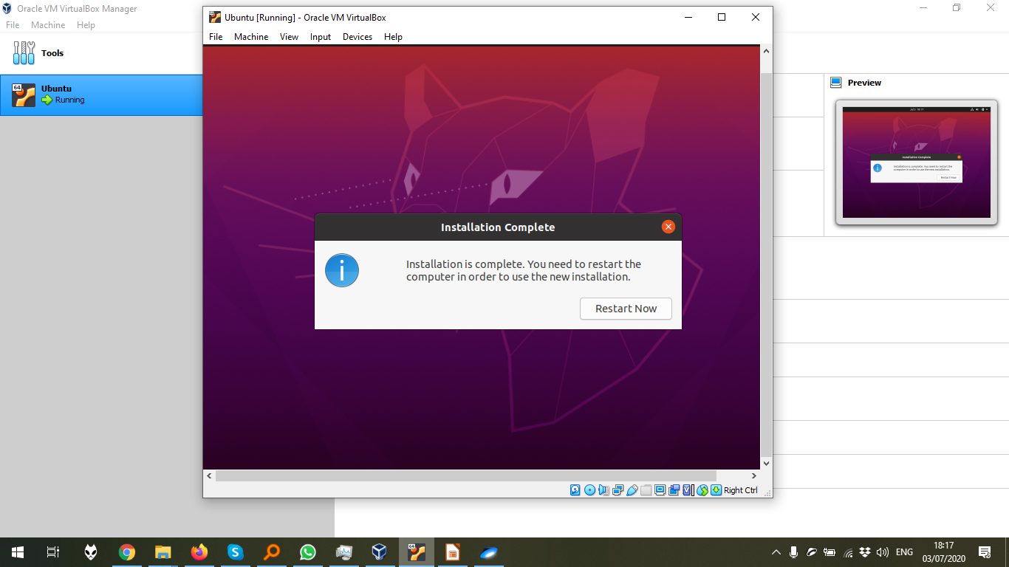
The desktop menu of Ubuntu 20.04, which was installed in the previous steps.
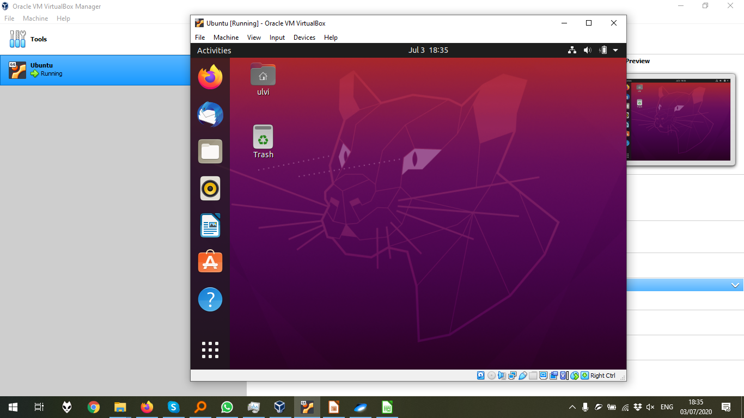

The crucial part: Adding external USB (My Wi-Fi adapter) to the list of ports. After that, the adapter should be plugged off, and after the OS loads, should be plugged on again.

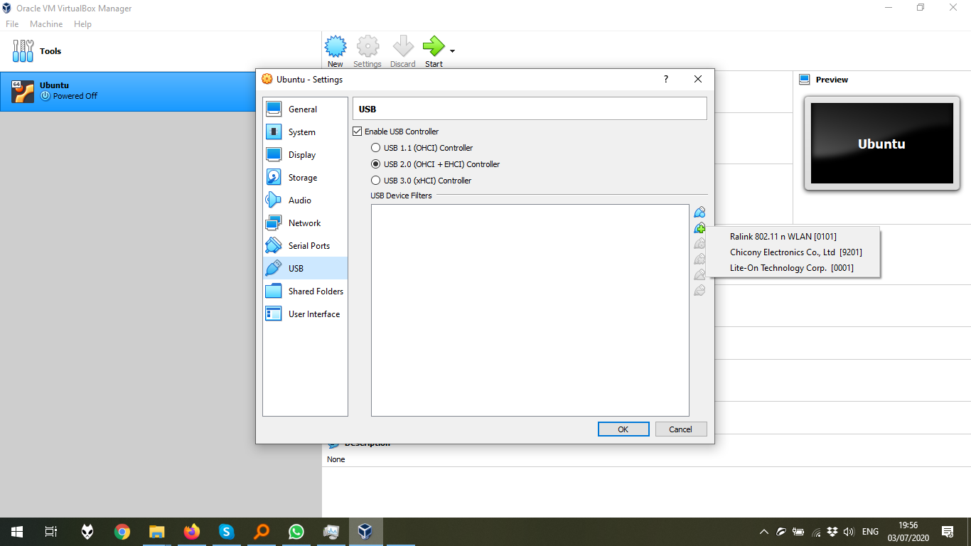
The wireless connection can be seen:
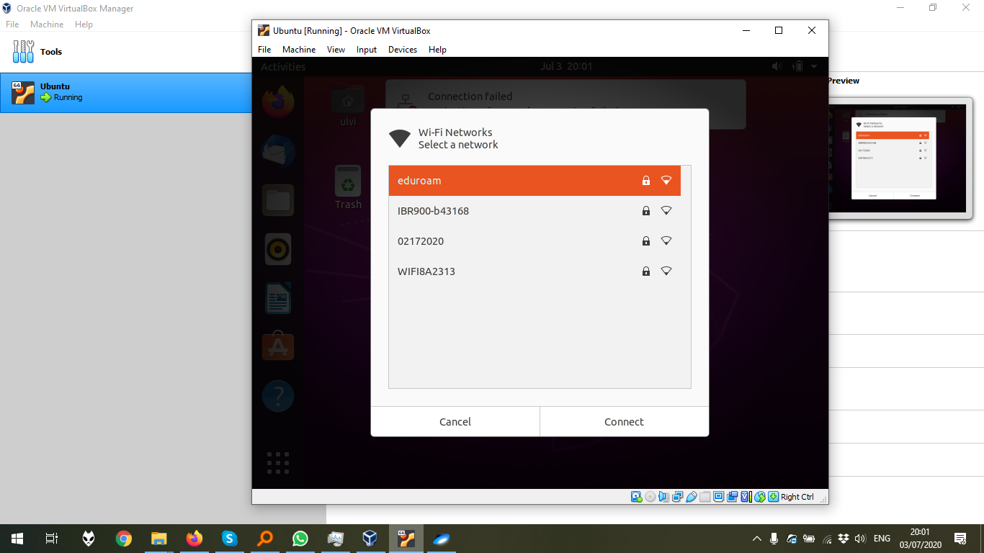

Despite that the pinging in terminal didn’t work, the internet works properly.

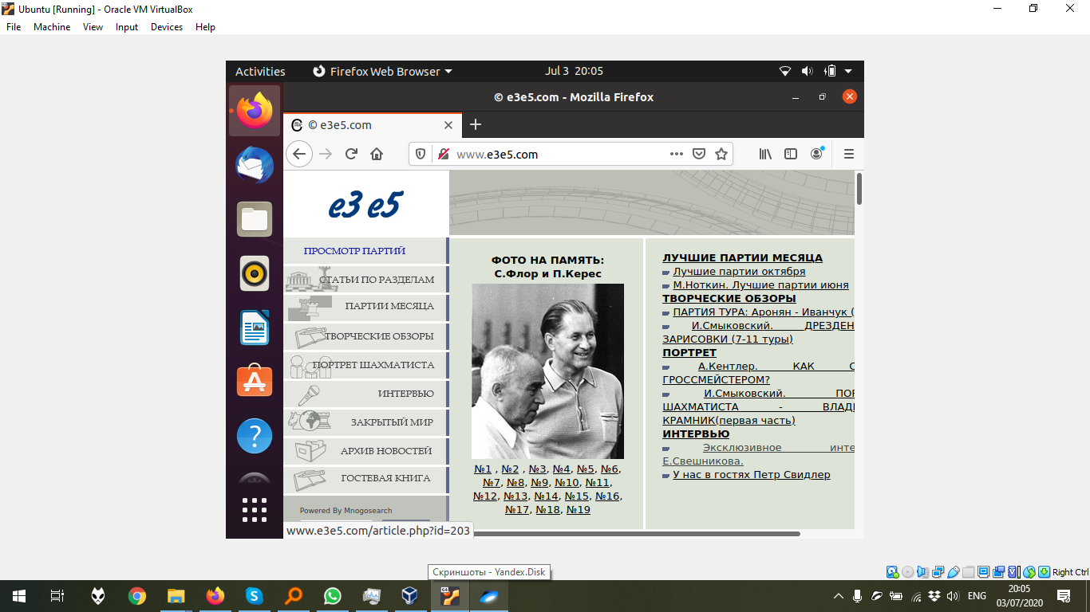

3. The lists of printers. Since that the author doesn’t have any printers, he will not add any printers.
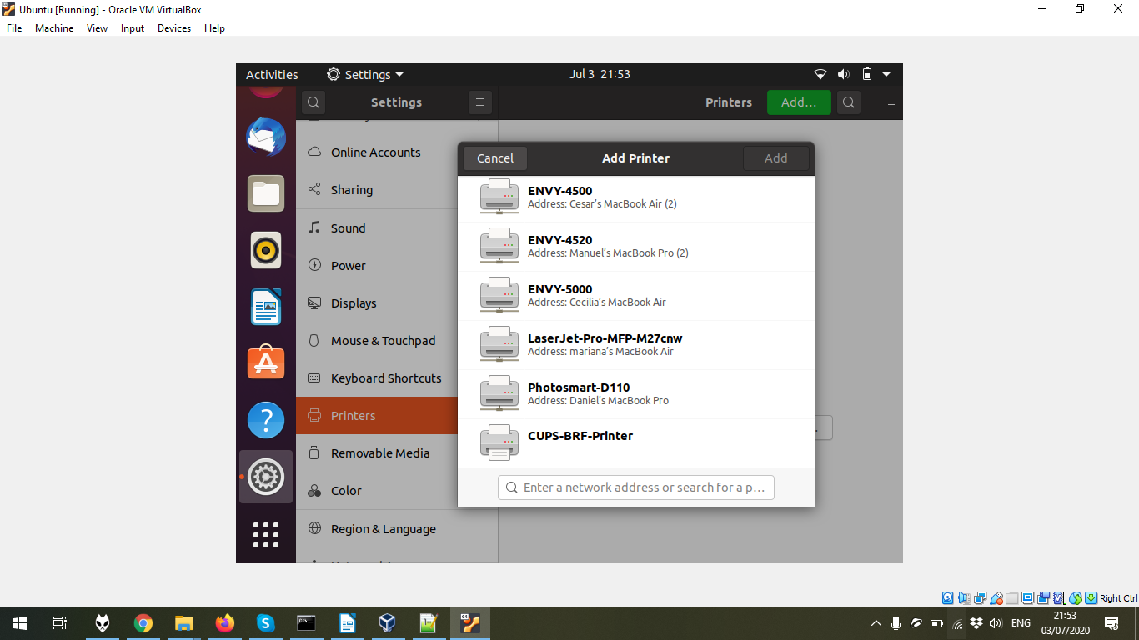

4. The execution of ifconfig command in the terminal. It should be noticed that at the moment, it is better to use ip a command, but ifconfig could be installed by sudo apt-get install net-tools, which had already been done in the tutorial before this step.

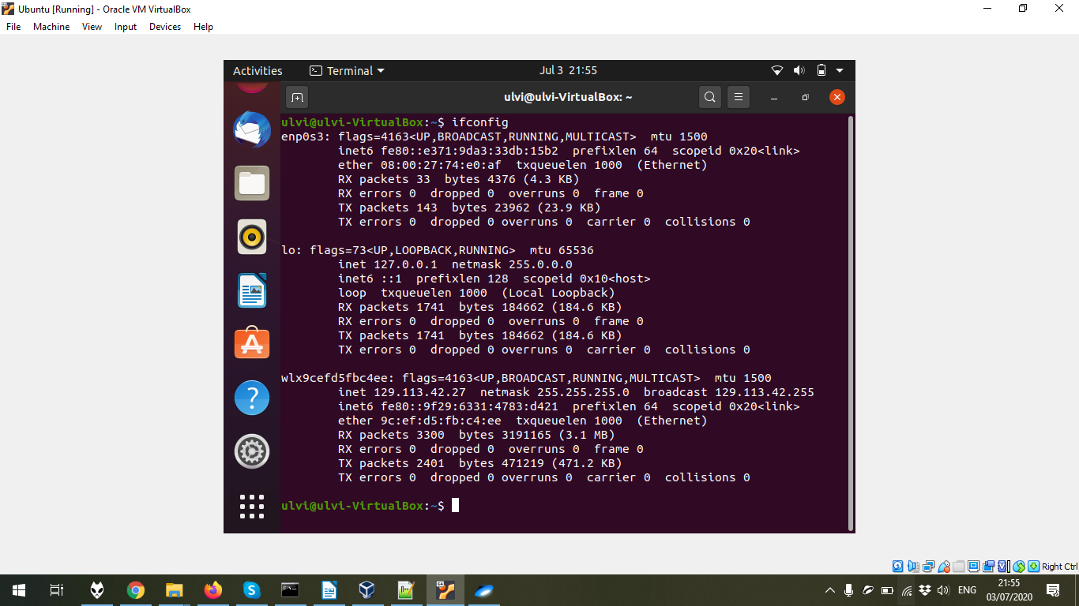

The consecutive execution of cp , ls , mv , pwd. Additional commands are executed to describe the result.


